**ARCHITECTURE DIAGRAM FOR LIBRARY MANAGEMENT APPLICATION**

Library management application is cloud native Spring boot application built with Angular JS as UI. It involves basic functionality of CRUD. Shown below is the schematic of the high-level architecture plan involved.

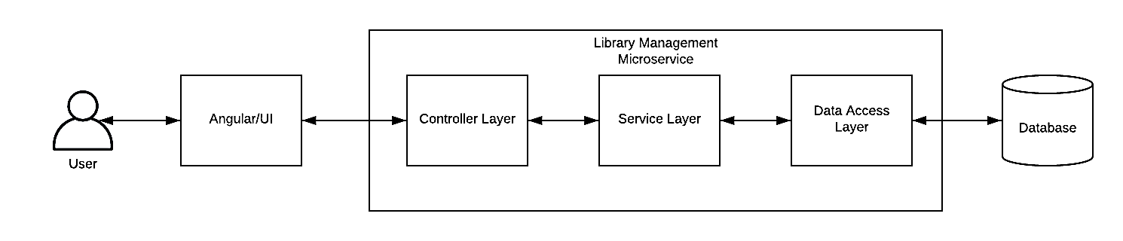

Fig 1. High-level Architecture Plan

**Screenshots**

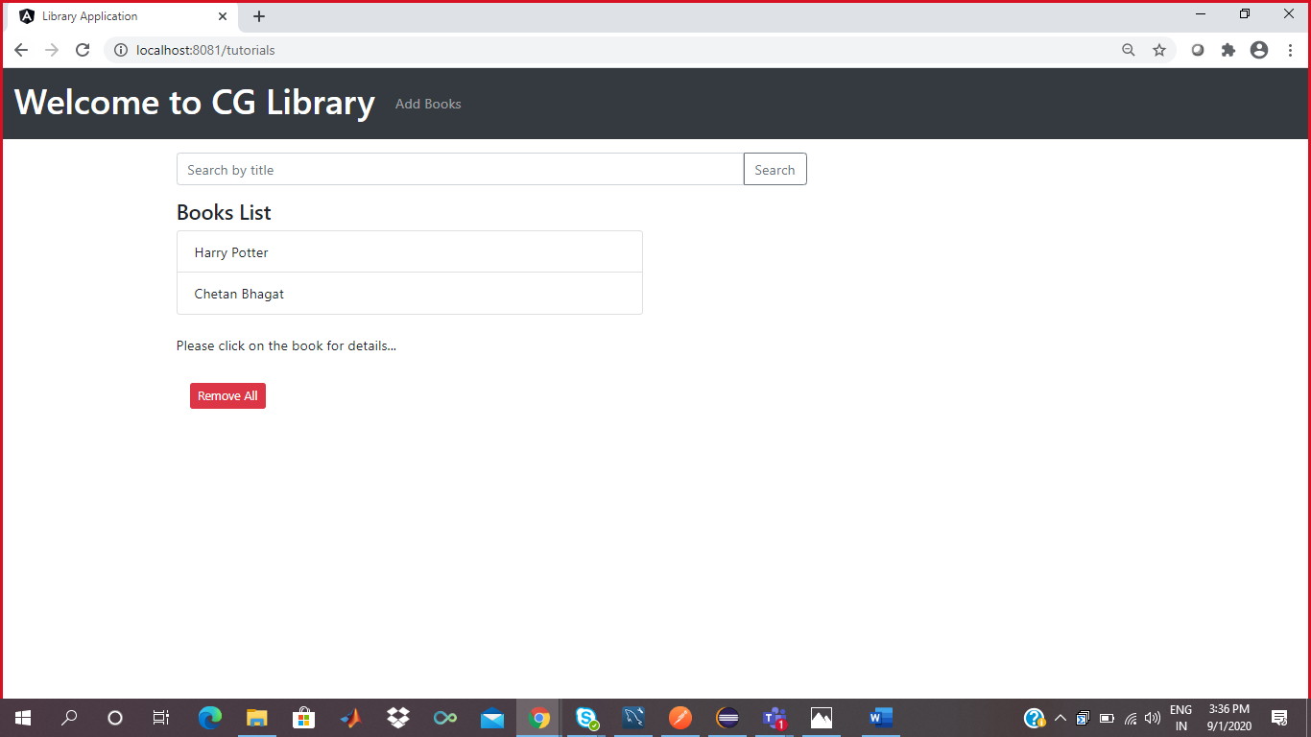

Screenshot of Home Page

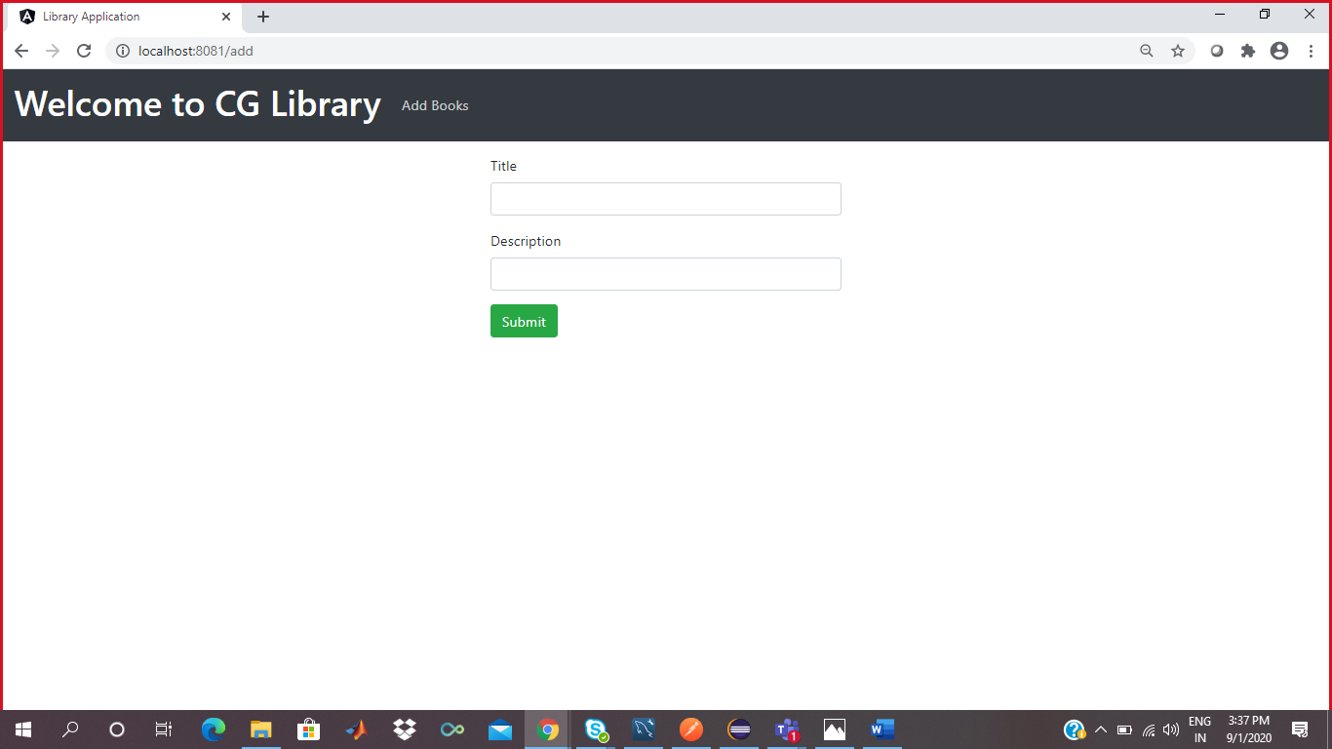

Screenshot of Add Page

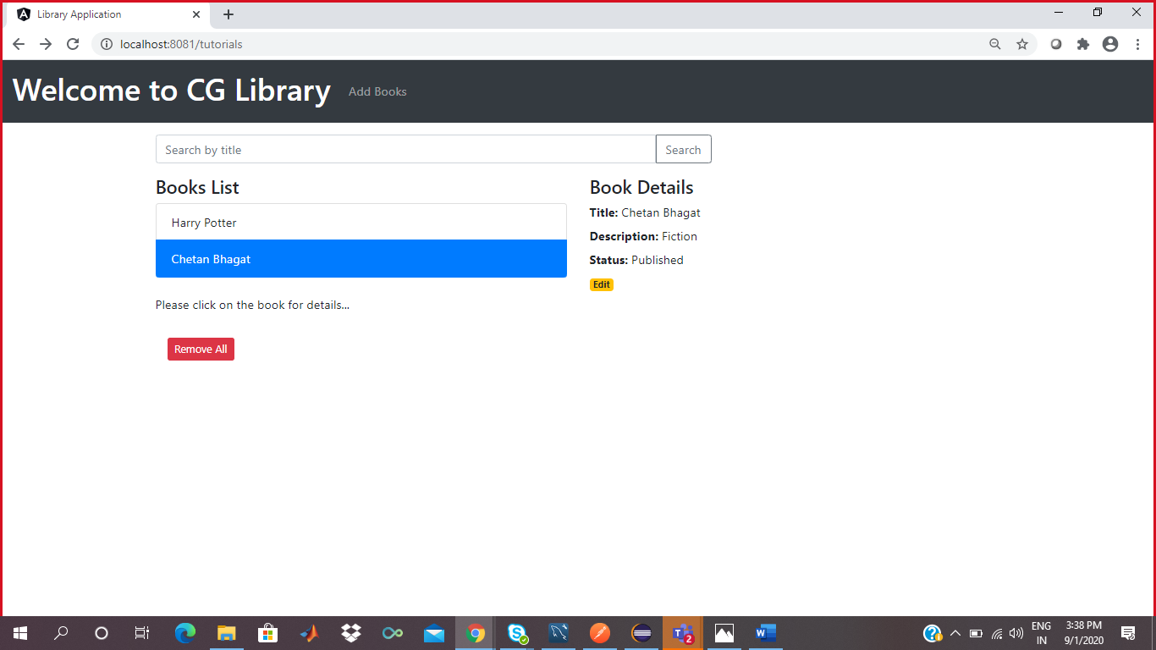

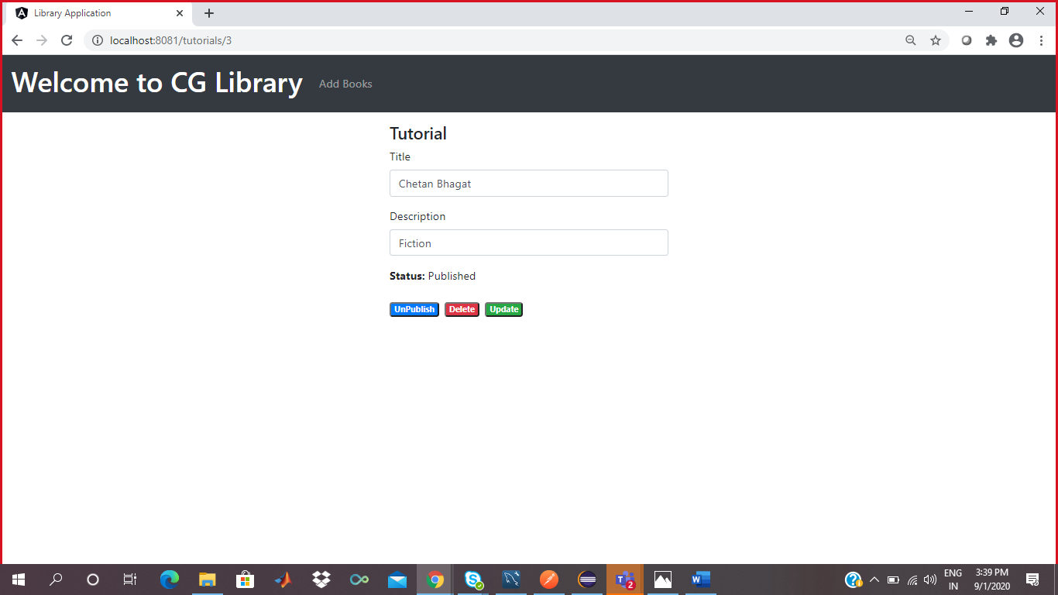

Screenshot of Update page